Date: December 9, 2015
To: Dr. Sheri Imsdahl, Professor
From: Kira Neuman, UW Mechanical Engineering
Subject: Project 3

Abstract
This report tests whether or not it is valid to model polydimethylsiloxane microposts as cantilever beams. Comparing the theoretical behavior of a beam with an ANSYS model confirms that finite element analysis can accurately reproduce the expected results. Analytically, the maximum displacement at the end of the beam is 0.1125 while ANSYS generates 0.113, an error of 0.44%. Using ANSYS to model a beam attached to base made of the same material yields a larger displacement, 0.132, and a 17.33% error, but the behavior is still a linear relationship with the amount of force applied. Overall, it is valid to model the micropost as a beam if the goal is to evaluate the general behavior and trends, but not valid if accurate numerical results are needed.

Introduction
Microposts made from polydimethylsiloxane (PDMS) can be used to measure the forces that are generated by cells as they crawl and contract. This method is used in lab tests by Professor Sniadecki at the University of Washington. Figure 1 shows an array of these microposts as captured by scanning electron microscopy. This report explores whether or not it is valid to assume that the micropost can be modeled as a three-dimensional beam. This is achieved by comparing the deflection of a of two PDSM beams, one with constrained displacement at the end and one attached to a base made of PDSM. The results were obtained with finite element analysis methods and computed in ANSYS software.

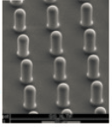
Figure 1. Image of an array of microposts

Methodology
The micropost analyzed in this report had base dimensions 3 $μ$m x 3 $μ$m and a length of 15 $μ$m. A pressure (p) is applied to one face of the beam, as shown in Figure 2. For PDMS, Young’s modulus (E) is 2.5 MPa and Poisson’s ratio (ν) is 0.449. Figure 3 represents an array of microposts with a cell on top, where δ measures the deflection at the end of the post.
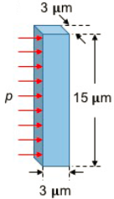
Figure 2. Diagram of micropost with dimensions and pressure, p

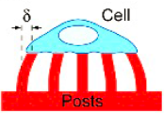
Figure 3. Array of microposts with cell and deflection (δ) at end of post

To begin, the analytical relationship between distributed load and deflection at the end of the beam was determined since this is the assumption being tested. It is known from beam theory that the maximum deflection of a cantilever beam, that is a beam where one end is fixed in all directions, can be expressed as:

$δ_{max}={ωL^{4}}/{8EI}$ (Eq. 1)

where ω is the distributed load, L is length, E is Young’s modulus and I is the area moment of inertia. For a rectangle, area moment of inertia is written:

$I= \frac{1}{12}bh^{3}$ (Eq. 2)

Since this problem has a given pressure, the distributed load is equivalent to the pressure multiplied by the depth of the face on which it is applied, the base (b) of the beam. Substituting this relationship and Eq. 2 into Eq. 1 shows:

$δ_{max}={12pL^{4}}/{8Eh^{3}}$ (Eq. 3)

Now that the analytical relationship is established, the micropost can be modeled in ANSYS. The volume was modeled using the dimensions listed above (Figure 2) and the properties of PDMS were set. SOLID187, a tetrahedral element with 10 nodes, was chosen since it can be meshed automatically by the software. The bottom face of the beam was given a fixed displacement load in the x, y, and z directions. A pressure of 1nN/$μ$m was applied uniformly to one side of the beam. Initially, the mesh was set fairly coarse, with only a few hundred elements. This was further refined to over 100,000 elements in order to ensure an accurate result. This model was than analyze and the deformed shape plotted over an outline of the original un-deformed shape (Figure 4) and the maximum displacement recorded for comparison with the results of Eq. 3.
Figure 4. Deformed and un-deformed cantilever beam under applied pressure

Next, the micropost was modeled with an attached base also made of PDMS in order to analyze the real physical geometry of the system. The beam still maintains the previous dimensions, but is now situated in the center of a large rectangle measuring 100 $μ$m x 100 $μ$m with a depth of 40 $μ$m, as illustrated in Figure 5.
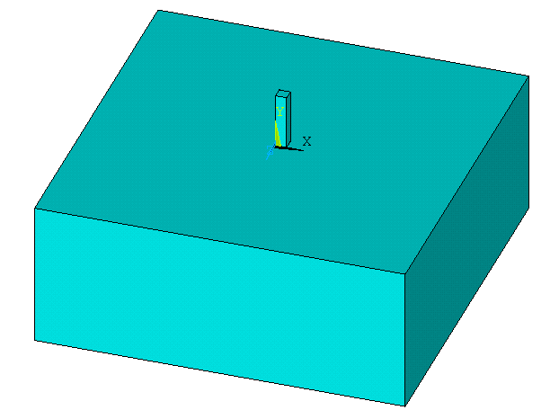
Figure 5. Model of beam centered on base

The same pressure was applied to this beam as used in the cantilever beam case. However, the dipslacement in all direction was fixed at the bottom face of the base. A similar strategy of mesh reinement was applied, however, only the elements in the beam and theare of the base closest were focused on. Figure 6 shows which surface elements were decreased in size and area extended approximately one third of the way into the base volume.

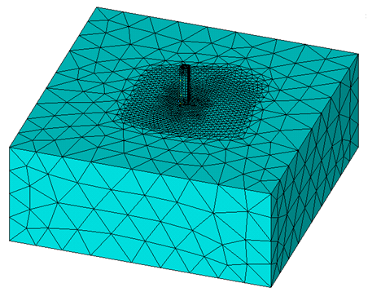
Figure 6. Beam centered on base with targeted mesh refinement

The solution was generated and the results plotted. Figure 7 shows a map of displacemtn varying from blue areas with little or no displacemnt and red for the areas of greatest displacement. The maximum displacement was also recorded and compared acationst the results of Eq. 3.
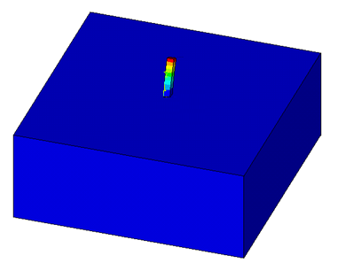
Figure 7. Displacement of the beam centered on base under applied pressure

Finally, the pressure on the model was changed from 0.2 to 2 nN/$μ$m in intervals of 0.2 and the maximum displacement recorded for each. These values were then graphed and compared to the analytical relationship in Eq. 3.

Results
Substituting values into Eq. 3 yielded an analytical maximum displacement at the end of the beam of 0.1125x10⁻⁵ $μ$m. modeling the beam at a cantilever in ANSYS yielded a maximum displacement of 0.113x10⁻⁵ $μ$m. Using Eq. 4, the percent error was 0.44% for this case.

$\% error= \frac{\left|actual-theoretical\right|}{theoretical}x100$ (Eq. 4)

Once the PDMS base was added to the beam, the maximum displacement was 0.132x10⁻⁵ $μ$m. The percent error in this case is 17.33%. The results from changing the applied pressure from 0.2 to 2 nN/$μ$m in intervals of 0.2 are recorded in Table 1 and graphed in Figure 8. The percent error was approximately 17% for all load cases.

Table 1. Pressure applied and resulting displacement at end of beam
Pressure (nN/$μ$m) | Displacement ($μ$m) [Analytical] | Displacement ($μ$m) [ANSYS] | % Error
.2 | .225 x10⁻⁶ | .264 x10⁻⁶ | 17.33
.4 | .450 x10⁻⁶ | .529 x10⁻⁶ | 17.56
.6 | .675 x10⁻⁶ | .793 x10⁻⁶ | 17.48
.8 | .900 x10⁻⁶ | .106 x10⁻⁵ | 17.78
1.0 | .1125 x10⁻⁵ | .132 x10⁻⁵ | 17.33
1.2 | .135 x10⁻⁵ | .159 x10⁻⁵ | 17.78
1.4 | .1575 x10⁻⁵ | .185 x10⁻⁵ | 17.46
1.6 | .180 x10⁻⁵ | .212 x10⁻⁵ | 17.78
1.8 | .2025 x10⁻⁵ | .238 x10⁻⁵ | 17.53
2 | .225 x10⁻⁵ | .264 x10⁻⁵ | 17.33

Figure 8. Applied pressure vs. displacement

Discussion
Comparing results from the two ANSYS models and the analytical solution reveals the relationship between the cantilevered beam and the beam attached to a PDMS base. ANSYS was able to produce the expected result for a cantilevered beam with only a 0.44% error, but had a 17% error with the base added. This model had a fairly fine mesh, so though further refinement may have yielded as smaller error it would have drastically increased the running time on the computer for only a small improvement in accuracy. The both configurations produced linear relationships between applied force or pressure and the displacement at the end of the beam. This means that both exhibit the same behavior patterns under varied loading, but that there is some error in the magnitude of the results. Ultimately, determining if it is a valid assumption to model the micropost as a cantilever beam will depend on the desired accuracy of the results.

Conclusion
This report uses finite element analysis software to demonstrate that a PDSM micropost can be modeled as a cantilever beam. However, this assumption is only valid if being used to study trends in results and is not valid if precise numerical results are needed. This is because the actual microposts are mounted to a PDSM base structure and although the same liner relationship between applied force and the maxim displacement is present, the error is amount of displacement is over 17%.

