Date: November 16, 2015
To: Dr. Sheri Imsdahl, Professor
From: Kira Neuman, Mechanical Engineering Student
Subject: Project 2
Abstract
A thin plate with a central hole was simplified using symmetry and modeled using ANSYS. After evaluating the stress distribution for a model with 943 elements, mesh refinement was used to show that the results converge further with finer mesh but that the computation takes significantly longer. Additionally, the stress concentration factor was calculated using the analysis and compared to the expected values. The methods produced very similar results and indicated that increasing the ratio d/w decreases the stress concentration factor.

Introduction
This is the second project for University of Washington’s finite element analysis course, ME 478. For this project, a thin plate loaded in tension with a hole through it (Figure 1) was analyzed using ANSYS in order to determine the stress concentration factor, Kt, as a function of the ratio of the hole diameter to plate size. It was also an exercise in exploring how mesh refinement affects the accuracy of results.
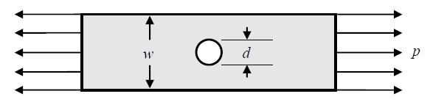
Figure 1. Thin plate with central hole

Methodology
In order to simplify the model of the thin plate, conditions of symmetry were applied. Since the hole is in the center of the plate and the pressure is applied equally to both ends, there are two axis of symmetry to consider. Each cut through the center of the hole, one vertically and one horizontally. This results in a model that is one quarter of the original plate (Figure 2). It is also important to apply boundary conditions to these new edges. On the vertical axis of symmetry, the model is restricted from displacement in the x-direction and on the horizontal axis the model is restricted from displacement in the y-direction
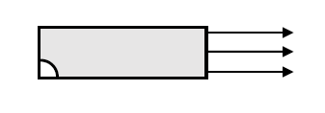
Figure 2. Simplified model after symmetry is applied

Now that the model is simplified, it can be built in ANSYS. Using element type PLANE82, he following material properties were defined: thickness t = 0.01 m, elastic modulus E = 200 GPA, Poisson’s ratio ν = 0.29. The area of the quarter plate was established, in a coordinate system with the origin located at the center of the hole, using key points as follows: keypoint 1 (.5, 0), keypoint 2 (.5, .2), keypoint 3 (0, .2), keypoint 4 (0, .1), keypoint 5 (.1, 0) and keypoint 6 (0,0). The corners were then connected by lines 1 through 5, and arc centered at 6 with radius .1 as line 5. Boundary conditions were applied by fixing the left edge with x-displacement of 0 and the bottom edge with y-displacement of 0. Finally, a pressure of 1.0 N/m^2 was applied to the right edge. The model with lines and keypoints labeled is shown in figure 3. Pressure is indicated by the arrow on the right; however the boundary conditions are not indicated graphically.
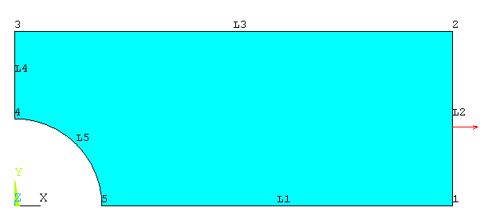
Figure 3. ANSYS model with defined area and applied pressure

With the model fully built, the next step is to apply the mesh. Initially, a mesh size of 0.01 m was chosen. The solution was then generated and the deformed shape, x-component of stress and Von Mises stress plotted in turn. Finally, by determining the maximum x-component of stress, σ_{x}, the following equation can be used to calculate K_{t}:

σx,max = Kt p w / (w – d) (Eq. 1)

The second task of this project is to determine the stress concentration factor Kt as a function of d/w by redoing the model with different values for the diameter of the hole. This was completed by generating the command log (Appendix A) for the steps completed above and modifying the coordinates of keypoints 4 and 5 the radius of the arc in line 5. The following table lists the diameters used and the corresponding command of the altered keypoints.

Table 1. Hole Diameter and keypoint locations
Diameter (m) | Coordinates of Keypoint 4 | Coordinates of Keypoint 5 | Radius of Line 5 (m)
.05 | 0, .025 | .025, 0 | .025
.1 | 0, .05 | .05, 0 | .05
.15 | 0, .075 | .075, 0 | .075
.2 | 0, .1 | .1, 0 | .1
.25 | 0, .125 | .125, 0 | .125
.3 | 0, .15 | .15, 0 | .15
.35 | 0, .175 | .175, 0 | .175

Results
The plots generated by the ANSYS model are shown in the following figures. Figure 4 shows the deformed shape of the plate with an outline of the original shape. Figure 5 shows the x-component of stress across the plate. Figure 6 shows the von Mises stress across the plate.
Figure 4. Deformed plate with outline of original plate

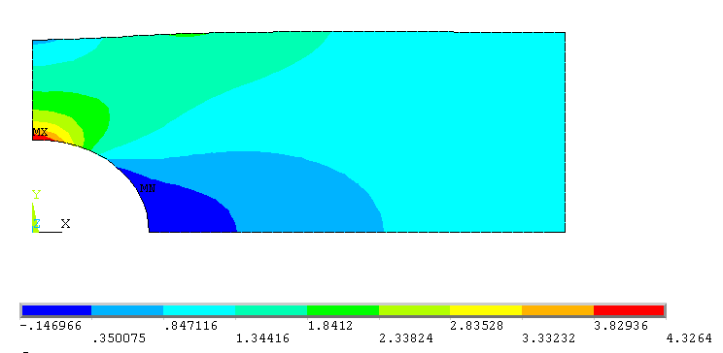
Figure 5. Distribution of stress in the x-direction

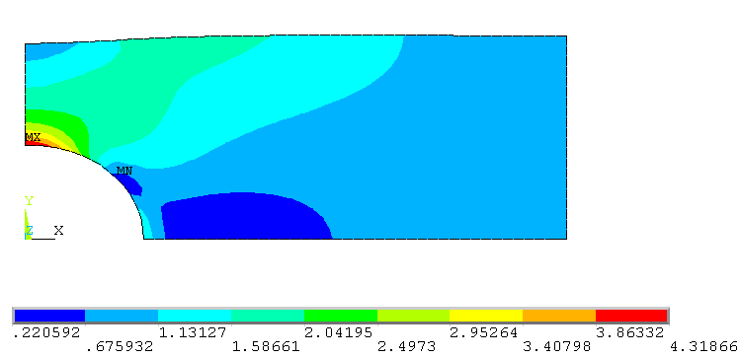
Figure 6. Distribution of von Mises stress

Though these results appear to indicate a convergent solution, this was evaluated by further refining the mesh using a Level 2 refinement and a separate Level 5 refinement on the original solution. This increased the number of elements from 943 to 8478 and again to 76383. The heat map for the von Mises stress experienced only slight changes, which confirms that the original element size was adequate for the model, though the value of maximum stress was about .02 lower than the more refined models. The maximum x-component of stress and number of elements are listed in Table 2 and the relationship is represented graphically in Figure 7, with an additional data point for a very course mesh.

Table 2. Convergence of max stress by number of elements
Number of Elements | 9 | 943 | 8478 | 76383
σ_{x,max} (Pa) | 3.98175 | 4.3264 | 4.34574 | 4.34849

Figure 7. Convergence of max stress by number of elements

For calculating the stress concentration factor, Eq. 1 was rearranged and evaluated with the values σx,max = 4.34574, p = 1.0, w = 0.4, and d = 0.2 to determine Kt = 2.17287. To determine the accuracy of the model, this can be compared to the expected result calculated with equation 2, Kt = 2.155875.

Kt = 3 – 3.14 (d/w) + 3.667 (d/w)² – 1.527 (d/w)³ (Eq. 2)

This gives the model a percent error of 0.78%.

To determine K_{t} as a function of d/w, the σ_{x,max} was recorded in Table 3 for 7 different hole diameters. The stress concentration factor was then calculated using both eq. 1 and eq. 2, along with the percent error for each diameter. The relationship is plotted in Figure 8.

Table 3. K_{t} for various d/w
W (m) | D (m) | d/w | σ_{x,max} (Pa) | K_{t} (from Eq.1) | K_{t} (from Eq. 2) | % Error
.4 | .05 | .125 | 3.00808 | 2.63207 | 2.661814453 | 1.12
.4 | .1 | .25 | 3.21229 | 2.4092175 | 2.420328125 | 0.46
.4 | .15 | .375 | 3.61538 | 2.2596125 | 2.257646484 | 0.09
.4 | .2 | .5 | 4.3264 | 2.1632 | 2.155875 | 0.34
.4 | .25 | .625 | 5.63227 | 2.11210125 | 2.097119141 | 0.71
.4 | .3 | .75 | 8.29932 | 2.07483 | 2.063484375 | 0.55
.4 | .35 | .875 | 16.3655 | 2.0456875 | 2.037076172 | 0.42

Figure 8. Stress concentration factor as a function of d/w

Using a best fit method through Excel, the equation of the line created with Eq. 1 is:

K_{t} = 2.9463-2.9227(d/w)+3.4639(d/w)²-1.468(d/w)³ (Eq. 3)

Discussion
Overall, ANSYS was able to provide accurate results for the model of the thin plate with a central hole. The exercise in mesh refinement demonstrated that a mesh too coarse will not be sufficient but that the accuracy quickly flattens (Figure 7) and further refinement only serves to increase the time taken for the computer to complete the analysis. In finite element analysis, the art is to find the balance of useable results and time taken. Additionally, using conditions of symmetry can be used to simplify the building of models without sacrificing accuracy.

This project also proves that an increasing ratio of d/w will decrease he stress concentration factor, because it greatly increase the maximum stress. In this situation, ANSYS again proved to generate good results (Figure 8).

Conclusion
The purpose of this project was to consider how mesh refinement can affect results, as well as look at the specific case of stress concentration factors in a thine place with a hole. The results confirmed that refining a mesh will lead the solution to converge, but that this costs time. In the thin plate, increasing the ratio of d/w lead to a large increase in the maximum stress and inversely proportional decrease in the stress concentration factor.

Appendix A
The code below creates a model of the quarter plate in ANSYS as described in the Methodology. It was modified and run to generate data for various hole diameter.

/BATCH
/input,menust,tmp,''
WPSTYLE,,,,,,,,0
/TITLE,project2
/prep7
et,1,plane82
KEYOPT,1,3,3
KEYOPT,1,5,0
KEYOPT,1,6,0
R,1,.01,
MPTEMP,,,,,,,,
MPTEMP,1,0
MPDATA,EX,1,,200e9
MPDATA,PRXY,1,,0.29
wpstyle,0.1,0.1,0,.5,0.003,0,0,,5
WPSTYLE,,,,,,,,1
k,1,.5,0
k,2,.5,.2
k,3,0,.2
k,4,0,.1
k,5,.1,0
k,6,0,0
l,5,1
l,1,2
l,2,3
l,3,4
larc,5,4,6,.1
al,1,2,3,4,5
ESIZE,.01,0,
MSHKEY,0
CM,_Y,AREA
ASEL, , , , 1
CM,_Y1,AREA
CHKMSH,'AREA'
CMSEL,S,_Y
AMESH,_Y1
CMDELE,_Y
CMDELE,_Y1
CMDELE,_Y2
FINISH
/SOL
FLST,2,1,4,ORDE,1
FITEM,2,1
/GO
DL,P51X, ,UY,0
FLST,2,1,4,ORDE,1
FITEM,2,4
/GO
DL,P51X, ,UX,0
FLST,2,1,4,ORDE,1
FITEM,2,1
/GO
DL,P51X, ,UY,0
FLST,2,1,4,ORDE,1
FITEM,2,4
/GO
DL,P51X, ,UX,0
FLST,2,1,4,ORDE,1
FITEM,2,2
/GO
SFL,P51X,PRES,-1,

