Date: October 26th, 2015
To: Sheri Imsdalh, Professor
From: Kira Neuman, Mechanical Engineering Student
Subject: Project 1

Abstract
Two variations of a shelf, one all steel and one with steel and composite, were analyzed using finite element analysis methods including analytical calculations and computer aided modeling with ANSYS. The displacements, reaction forces, and maximum stresses were compared. The shelves performed similarly, though shelf with the composite member experienced lower maxim stress and loess displacement. However, once cost is considered, the all steel shelf is still a good choice for most applications.

Introduction
In order to calculate the maximum stress and deflection of a steel shelf, the support structure was analyzed using finite element analysis (FEA). The goal was to compare the results from analyzing an all steel support structure with a structure that round, composite tube as the diagonal member. The modeling was simplified to two-dimensions, as represented in Figure 1, since the shelf and loading are symmetrical. The analysis was performed analytically, and the results checked using the FEA software ANSYS.

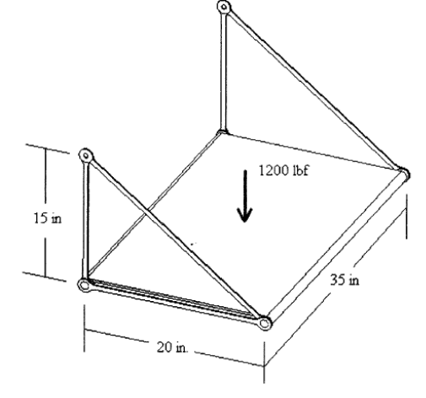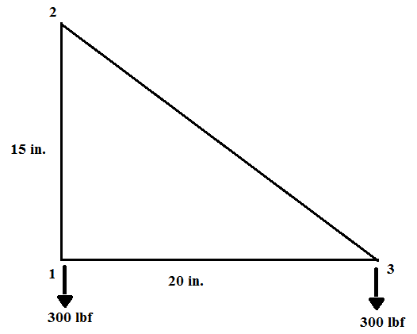
Figure 1. Diagram of Shelf in Three-Dimensions and Corresponding Two-Dimension Model

Methodology
In order to model the shelf as a truss structure, any twisting of the elements and rotation about the nodes was neglected. It was assumed that nodes 1 and 2 were pin supports and therefore unable to move in either x-direction or y-direction; this would represents the locations where the shelf would be bolted to a wall. Additionally, the 1200 lbf load in the middle of the shelf was treated as 300lbf applied to each of the shelf platform’s corners due to symmetry. The material properties for steel and composite are given in Table 1.

Table 1. Material Properties
 |  | Steel | Composite
Cross Sectional Area | A (in^2) | 0.125 | 0.3
Elastic Modulus | E (psi) | 30x10^6 | 2x10^7
Poisson’s Ratio | ν | 0.27 | 0.4

To calculate the nodal displacement and forces, the equation F=K*d was used, where F is the global nodal force vector, K is the global stiffness matrix, and d is the nodal displacement vector. The boundaries conditions applied were u1=v1=u2=v2=0 and a force of 300 lbf was applied to nodes 1 and 3. First, the stiffness matrix was assembled and partitioned, which allowed the unknown displacements, u3 and v3, to be determined. Then the global stiffness matrix was used to find the total forces. Finally, the applied forces were subtracted from the total forces in order to see the reaction forces. The complete calculations for both the steel and composite members can be found in Appendix A.

Computing this analysis using ANSYS, Link 180 was selected as the element type since it is a truss. Two sets of Real Properties and Material Properties were defined. Set 1 represented steel and Set 2 represented composite. Nodes were created by coordinates as follows: Node 1 (0,0), Node 2 (0,15) and Node 3 (20,0). Element 1 and Element 3 were both created using the properties of Set 1. Element 2 was defined by Set 1 for the all-steel shelf and Set 2 for the composite-steel shelf. ANSYS then computed a solution, plotted the deformed structure, and listed displacements and force for each node, and listed axial force and stress for each element.

Results
The calculations show that both shelves have the same reaction forces, but the composite shelf has a slightly decreased y-displacement at node 3. The results from the two methods, analytical and ANSYS, were very similar. The small discrepancies were likely due to rounding since the computer is capable of carrying more digits following the decimal. The displacement and reaction forces are listed in Table 2. The deformed structure for all-steel and composite can be seen in Figure 2 and Figure 3 respectively. ANSYS also determined that for the all steel shelf, the maximum stress in 4000 psi and is located in element 2. However, when that bar was replaced with the composite, the maximum stress was 3200 psi and was located in element 3. This makes sense because the composite material has a larger cross sectional area, both shelves have the same nodal forces and stress is defined as force per area. Since the yield stress of steel ranges from about 40,000 psi to 232,000 psi, neither shelf will fail due to stress.

Table 2. Comparison of Displacement at Node 3 and Reaction Forces at Nodes 1, 2, & 3
 | Analytical |  | ANSYS
 | Steel | Composite | Steel | Composite
U3 (in.) | -0.00213 | -0.00213 | -0.0021333 | -0.0021333
V3 (in.) | -0.0084 | -0.00632 | -0.0084 | -0.0063167
F1x (lbf) | 399.375 | 399.375 | 400 | 400
F1y (lbf) | 300 | 300 | 300 | 300
F2x (lbf) | -400.32 | -400.896 | -400 | -400
F2y (lbf) | 300.24 | 300.67 | 300 | 300
F3x (lbf) | .945 | 1.521 | 0 | 0
F3y (lbf) | -0.25 | -0.673 | 0 | 0

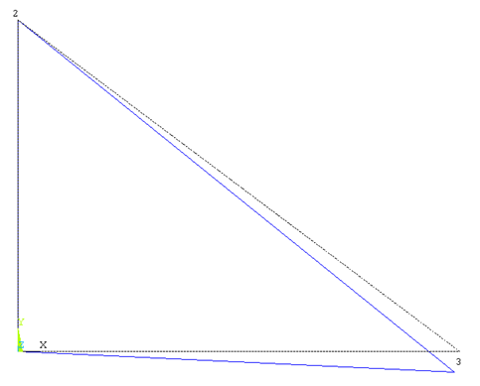
Figure 2. Deformed Structure (all steel)
Figure 3. Deformed Structure (composite and steel)

Conclusion
Overall, neither shelf had a significant advantage in performance. Both analytical calculations and the ANSYS model indicated a smaller displacement when the composite replacement was added. Though this also resulted in decreased maximum stress and switched which member experienced the maximum, neither shelf is at risk of yielding. However, steel is generally more affordable than composites so would be a better choice for most applications of the shelf.

