- ABSTRACT
STEM, in the United States, is an acronym that stands for “Science, Technology, Engineering, and Mathematics.” Modern-day technology has made it such that, in this day and age in developed countries, it is the norm method of staying updated and interacting with other people. In addition, today’s job market in Europe consists of a growing number of STEM related jobs in several countries. As a result of technology’s wide and growing influence, it follows that naturally part of how people learn about their own countries and, consequently, themselves is through what they hear and see in the media. In this joint research effort, we will explore the narrative as to how technology is shaping a part of youth education as well as how it is being used to express the issue of unemployment.
Sonja’s focus lies in the choice of major of young students who are growing up in the midst of this economic crisis. Specifically, her interest evolved in STEM education and how government policies and the school system may or may not be encouraging students to study the STEM fields, and how these policies are being felt by students and teachers.
Kira will investigate how students and educations interact, focusing on the purpose of an education in light of the Eurozone crisis. Perspectives of students will be compared with those of institutions to identify any conflicts or incongruities.
In her research, Jessica will present an analysis of social media’s role in educating the public about unemployment in the Eurozone and the collaboration of nations in an attempt to combat rising unemployment rates. More specifically, she will attempt gauge the public in Berlin and León’s awareness of the recent collaboration between Germany and Spain to help promote jobs for youth. In addition, she will analyze how this topic in the news is being perceived by people in both Germany and Spain in an attempt to see if people in either country identify strongly with nationalistic views for their own country. With the recent collaboration between Germany and Spain to help provide Spaniards with access German jobs and job training questions have risen as to whether this agreement would actually help Spaniards and Germans. One of the conflicts surrounding this agreement is that some tend to see the German education system as inherently “German,” and so the fact Spaniards are going abroad to learn German skills presents itself as a potential threat to the preservation of Spanish culture. Of course, there remains the question as to what constitutes the culture, or “national identity,” in each of the regions in the first place, which is arguably a still widely contested concept.

- QUESTION

How does the economy affect how students perceive the purpose of a university education? Does this perception have an effect on the skills the university provides?
With the economic crisis putting stress on the job market, students are under pressure to plan for the futures as soon as possible. One of the biggest decisions faced is choosing a career path. I am interested in investigating the relationship between institutions and the individuals they serve. This includes finding out if any changes have been made in the expectations placed on Universities and/or students and if there is a correlation between their interactions and the ability of youth to enter the work force following their education. I am also interested in seeing if there is a discrepancy between what students wants from their education and what the education system wants to provide. Although, I was initially interested in all educational paths (university, technical school, vocational training, etc.), the resources and time available caused me focus more on university students. This restricts my research some, since university students already have made choices that lead them down the same path and are less of a diverse group. However, it is a more manageable investigation for the program.

- BACKGROUND

The current economic crisis is one that is not restricted by borders. It is felt in many cases around the world. The Eurozone crisis, however, is slightly different as it affects the countries within the European Union using the same monetary unit but with different economic situations. The main problems are high debt in some member countries, weak banks, high unemployment in some countries, and trade imbalances [1]. This paper will be focusing on youth unemployment (usually defined as 26 years old and younger), but it is import to understand that the economy is multi-faceted.
I. Unemployment
Germany currently has one of the strongest economies in the EU, while Spain has one of the weakest. The youth unemployment rates reflect this fact quite well. In general, youth unemployment in the EU skyrocketed in late 2008, and then again in 2011, resulting in almost twice the rate in the past five years. As of 2012, Germany had an overall rate of 5.5% and youth rate of 8.1%. Meanwhile, Spain was at 25.0% overall and 53.2% for youth, though this has since risen towards 60%. [2]
Given the vastly different rates in these two countries, it is clear that there must be one or more major differences contributing to the situation. Education is the foundation for society to grow upon, so is a clear place to begin investigating. I looked at the structure of the education systems in Germany and Spain, and considered the various viewpoints on the end goals of education in order to have the knowledge to analyze the current issues.
II. Theoretical Background
The purpose of education can be viewed in many ways, often fitting with a person’s larger ideologies. For example, some people believe that education is meant to prepare children for work, other to teach them how to learn, and some believe education is about integrating into society. The mainly theories applied can be narrowed down to structural functionalist theory, conflict theory, and interactionist theory. Functionalist theory would consider the main purpose of education to be binding society together. This is achieved through socializing children, passing on culture and values, and deciding their proper role in society as an adult. Conflict theory is based on the works of Karl Marx and places education is a perspective revolving around class dominance. The main idea is that education is meant to create an obedient society in order to maintain the capitalist social order. This is accomplished by teaching youth to follow the orders of authority figures and become used to a system based on competition with peers. Both Functionalist and conflict theories use meritocracy, or the idea that those who work the hardest will have the best rewards. On the other hand, symbolic interactionism places more importance on the individual, and less on the larger society. It views school as a source of interactions that can shape an individual and their beliefs about self and society. These ideologies are personal, but can influence the development of an educational system as well as the attitudes that a society has as a whole. [3]
The role of universities has changed throughout time as well. Originally created to bring together the best researchers and academics, a university education was limited to only a small number of highly qualified students. However, they have evolved over time so that the focus is split between research and teaching, with attempts to be accessible to a wider population. Recently, a variety of university presidents and deans were asked to give their opinions on what college is for. Through their answers highlight many different aspects of education, they all carry the message that the purpose is “to teach students how to learn, how to find information, and how to work collaboratively across disciplines and cultures” so that students have the flexibility to purpose many professions [4].
III. Education Structures
The German education system is different from both the American system I am accustomed to and the system used in Spain. It is under the control of the state rather than federal government, o there are regional variations, but the general structure is the same. After 4 years of general education, students attend one of three types of schools, a decision made in part by parents with the referral of teachers. The Hauptschule, a five year program, is designed to prepare students to enter the work force or vocational training. The Realschule typically leads to vocational or job specific training after six years. The Gymnasium is the most difficult of the three options, taking up to nine years, and prepares students for university. Additionally, Germany has a dual education system that combines traditional learning with apprenticeship positions. Students in this program will spend the last years of the high school education splitting their weeks between practical experience and classroom time. There are usually more than 400,000 positions available annually and many go unfilled. Approximately 60% of German students will choose a path like this [5].
The Spanish education system has more connections with the Catholic Church than the systems in either the U.S. or Germany. Most schools are public, but there are many private schools and semi-private schools. The latter types are typically religious which is why they are not entirely funded by the state. Education in Spain is mandatory until the age of 16, when students have completed the first two years of high school. The next two years make up the Bachillerato and are the preparation for university exams. Students will choose to focus on Arts, Letters, Social Science, or Pure Science based on their interests. The scores following these two years will determine whether they can attend university and what they are qualified to study [6].
IV. Fields of Study
In order to have an overview of higher education, I compared at the percentages of students in different fields of study in Germany, Spain and the United States [2]. I wondered if there was any obvious relation between the distribution of students and unemployment, such as the majority of students studying the same field and therefore competing for the same jobs. The statistics did not have any immediately surprising results; the general popularity of each choice is similar in all countries. However, it was interesting to see the more dramatic differences in Spain between “Science, math & computing” and “Engineering, manufacturing & construction.” The two are about 2% different in Germany and the US, but 8% in Spain. This would indicate that there is some influence that is Unique to Spain.

Students in Tertiary Education, 2010
 | Total number of students in tertiary education (1000) | Of which, studying (%)
 |  | Humanities & arts | Social sciences, business & law | Science, math & computing | Engin., manuf. & construction | Agricul. & veterinary | Health & welfare | Services
Germany* | 2,556 | 13.7 | 26.2 | 14.2 | 16.4 | 1.4 | 17.9 | 2.8
Spain | 1,879 | 10.6 | 31.4 | 9.1 | 17.3 | 1.7 | 12.6 | 5.8
United States | 20,426 | 15.1 | 27.7 | 8.6 | 7.2 | 0.7 | 14.6 | 6.2
*Excludes students enrolled at ISCED 6.

- Methodology

I used a combination of research methods, primarily surveys and interviews, as well as gathering information through personal observation and from various guest lectures and texts. Each method has strengths, but all were limited by the time constraints of the program.
I. Lectures
The guest lecturers who visited us throughout the program had varying levels of relevance for my topic. For the topics that were directly related, the speakers provided an expert opinion focused specifically on one issue which help fill in may details for my research. However, sometimes the guests did not have the information to answer the questions posed as their field was too narrow. Many of the topics were not related at all but the speaker would say one or two things that would cause me to reconsider the framework for my question.
II. Survey
As a group, we were able to collectively write an anonymous survey that touched upon various aspects of our research. The surveys were not created until we had already sent some time gathering information in order to better select the most important questions to ask. This survey was double-sided, consisting of 9 questions printed in both English and either German or Spanish, for use in Germany and Spain respectively. The questions asked students to give a ranking, select the best answer, or write a short answer. The surveys were passed out to classes at Humboldt University in Berlin and the University of Leon’s Language Center. The benefits of a mass survey are that we were able to collect a larger sample size and written questions do not rely on the ability to communicate verbal in various languages. However, the samples are not a balances representation of the youth in either country. In Germany the students mostly in American Studies, which requires competency in English and the students in Spain were mainly studying the English language. Therefore, we have a limited perspective of only English speaking youth, enrolled in high education and living in either Berlin or Leon.
It is also important to consider the biases that the students themselves may hold. First, the survey asked them to give reasons for choices they made in the past. Their narrative may be adjusted to put their past and present in a positive light. Additionally, socially desirability may have affected the students’ answers either consciously or subconsciously. It has been found that unpleasant or embarrassing fats tend to be underreported, while ideal behaviors are over-reported [7]. In this case, there is a change that students under reported the influence that job prospects had on their decisions, thinking they will make a better appearance by stating that they are following their interests. Since the survey was written, it had a higher level of anonymity than face to face surveys, which should minimize the effect of social desirability bias [7].
III. Interviews
My final method was interviews. I spoke with a variety of people, including professors, students and guest speakers, getting many unique perspectives. These interviews were loosely structured; I would ask about their personal experiences with education and see what they elaborated on. I would then ask more specific questions to clarify points they made or refocus the conversation to my topic if necessary. The interviews have the benefit of being detailed and personalized to the person’s experiences. However, I did not interview a large number, or a particularly varied group, so there may be some incongruity between my findings and the opinions of society as a whole.

- Findings

Comparing the perspectives of students, teachers, and others involved in the education system revealed the relationships in each country. Some information was given directly by the source, while some can be drawn out by combining new information with background information.
I. Germany
In Germany, I spoke with a university professor about his experiences as an educator as well as those of a parent of a young adult [8]. He explained that while students are in secondary school (his experience is with the gymnasium in particular), students work very hard to prepare for university exams. There are a series of examinations, both oral and written, that determine whether they are able to enter a university. The topics of focus are chosen by the students; some focus on math and sciences, while other focus on humanities or social sciences. He felt that his child was well prepared by the system to enter university, noting that she is doing quite well in her studies so far.
He then spoke more about his job and expectations as a professor. As a faculty member in a social science field, he feels that his priority is to prepare students to enter the intellectual side of their degree program. They study theory and learn how to develop their own ideas and present them to the class. There is no focus on training students for the work force, unless they intend to enter academics.
The opinions of a professor only tell half of the story; it is necessary to get the perspective of a student as well. I was able to speak with a graduate from the same university, and in fact from the same department as the professor. This student was unemployed for about a year following graduation, then worked at the Job Center in Berlin, before settling into his current job [9]. He explained that it was initially hard for him to accept that he was unemployed, but felt that the main reason was because the jobs available did not fit his expectations, not that there weren’t jobs at all. When asked if his university had helped him prepare for the working world, he seemed surprised. He then elaborated that the university career center offered seminars and classes on topics like interviews and writing a resume and that every student was required to attend a certain number of these during their time at university.
II. Spain
In Spain, I spoke to teachers from different levels of the education system. They included a preschool teacher, a middle school technology teacher, and a few university language professors. Most enlightening was the technology teacher. She had a degree in industrial and systems engineering and had returned to the Leon language center in order to earn certification for bilingual classrooms. She told me that there was a higher demand for “useful” subjects in schools now as parents want their children to have a good future [10]. However, the crisis has also caused cutbacks in the education budget and put a financial strain on the system. The university professors also noticed an increase in popularity for classes in which there are applications for the knowledge, such as foreign languages and programming.
In addition to Spanish educators, I was able to interview university students in Leon. They were all taking either English or German classes. One young male said that he was currently unemployed, with a degree in videogame design, and was studying English in order to expand his job prospects in the field [11]. He reported that the career services at universities are available for students who are interested. However, he felt that while they could help create a strong resume, there is no way to create offers when the jobs just aren’t available.
III. Survey Results
The surveyed students came from a variety of backgrounds according to their survey responses. However, with such a limited sample, it is not possible to see connections between the survey answers and demographics such as age or gender. There was one survey question directly related to my question. The question read:
In your opinion, what is the purpose of a university? (Rank in order of importance)
Job preparation
Personal Development
Prestige
Other: ______
Of the surveys returned, I was able to draw data from 32 German students and 27 Spanish students. The graph below shows the percentage that selected each category as the most important function of a university.

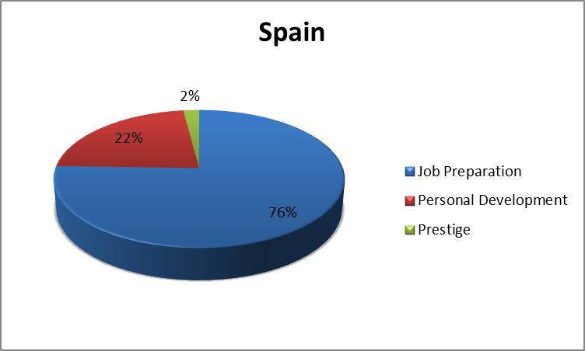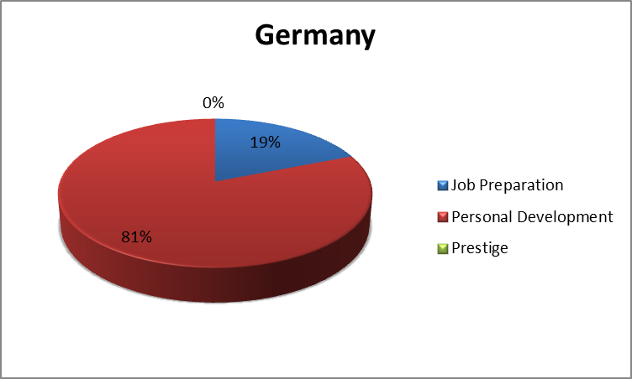

The results were dramatically different with the majority in Spain choosing job preparation while the common answer in Germany was personal development. Given that the sample sizes were relatively small and do not represent a variety of students (almost all German students were females in American Studies, in Spain they were all language students), this result cannot be considered definitive. The responses from Germany fit with the idea that universities are need to create life-longer learners, while Spain indicates a job oriented attitude. There are a few possible explanations for these numbers. There could be a fundamental difference in the sample of students and/or the culture of the two countries, but it is more likely reflective of the economic crisis. Since Germany’s youth unemployment is low, the students have time and energy to focus on other aspect of their education. In Spain, the need for jobs is much higher and is therefore a priority to many students.

- Conclusion

With the time constraints of the study abroad program, it is difficult to draw any broad conclusions. The data shows that in Spain, there is a stronger focus on jobs. Given that their economy is currently not as strong as it is in Germany, this makes sense. Looking back at the three theories behind education, arguments could be made for all theories. In my opinion, Germany and Spain both are following conflict theory principles. Looking at their education structures, children are sorted into their societal roles during elementary or primary choosing when they must decide which professional path to follow. This determines early on which class most people will be able to end up since there is not much movement between students in the various secondary systems. However, it seems that the students in both countries view their education differently. The German students surveyed and interviewed believed in personal development and learning, focusing on their own interests. This would fit more with the theory of symbolic interactionism since there is more focus on the individual. Meanwhile, Spain seems to be transitioning to a functionalist theory ideology, though it is not necessarily what the education system is currently providing. The desire to be prepared for jobs and have a cohesive society reflect this, though the fact that unemployment is high suggests it is not working perfectly by any means.
Following this study, it would be interesting to continue to follow the education systems in these countries, particularly Spain and others suffering most from the Eurozone Crisis, to see if there are any changes made to attempt to combat youth unemployment. Form the research done on STEM education and the new agreement between Spain and Germany, there may be new opportunities for students entering STEM fields if they are properly prepared by schools.

- REFERENCES

[1] United States of America. Congressional Research Service. The Eurozone Crisis: Overview and Issues for. By Rebecca M. Nelson, Paul Belkin, Derek E. Mix, and Martin A. Weiss. N.p., 26 Sept. 2012. Web. 21 July 2013. <http://www.fas.org/sgp/crs/row/R42377.pdf>.
[2] Eurostat. European Commission, May 2013. Web. 20 July 2013. <http://epp.eurostat.ec.europa.eu/portal/page/portal/eurostat/home/>.
[3] "Education Overview." Web log post. Sociology at Twynham. Twynham School, 2013. Web. 15 July 2013. <http://sociologytwynham.com/>.
[4] Wise, Phyllis M., Carolyn A. Martin, Walter M. Kinbrough, John C. Hitt, Charles G. Lief, Michael V. Drake, Brenda Hellyer, William Pepicello, and Joseph R. Urgo. "What Is College For?" Editorial. The Chronicle of Higher Education. The Chronicle of Higher Education, 22 Apr. 2013. Web. 22 July 2013. <http://chronicle.com/article/What-Is-College-For-/138683/>.
[5] Carroll, Caitlan. "Germany's Dual Vocational Education System - Young Germany." Young Germany. Societäts-Medien GmbH, 18 July 2013. Web. 22 July 2013. <http://www.young-germany.de/topic/study/courses-degrees/germanys-dual-vocational-education-system>.
[6] "Spain - Educational System—overview." State University. Net Industries, 2013. Web. 28 July 2013.
[7] Kaminska, Olena, and Tom Foulsham. "Understanding Sources of Social Desirability Bias in Different Modes: Evidence from Eye Tracking." 2013.
[8] "Humboldt University Professor." Personal interview. 28 June 2013. [9]"Student in Germany." Personal interview. 29 June 2013.
[10] "Technology Teacher in Spain." Personal interview. 16 July 2013.
[11] "English Student in Spain." Personal interview. 17 July 2013.

- CULTURAL SENSITIVITY

Entering this study abroad program, I was unsure what to expect, both educationally and personally as we travelled together. My question of interest was not fully formed upon finishing the spring prep seminar and it constantly changed and time progressed. The language barriers also complicated things; I was constantly both impressed and humbled by the supposedly “poor” English spoken by our guests. As a student, it is important that I understand my own role in society and make the best choices for myself. Unemployment is something I plan to avoid, but that is true of the many unemployed youth today as well. Our world is continually becoming smaller as technology makes distance arbitrary. There really is no such thing as a problem that only effects on region, especially the youth are playing a crucial role. Our future is a shared one so everyone has an equal stake in development of global society, education, and the economy.
Aside from the academic aspect of this program, I learned a lot about myself and the world. There are so many things I have not done and I tried to experience as much as possible while on this trip. All of the museums, historical locations, and culture landmarks expanded my knowledge of Europe greatly. Probably even more impactful, experience the culture and daily life in both Berlin and Spain taught me how to adapt to unexpected situations and be open to all kinds of lifestyles. I met so many interesting people and made many bonds with my peers. I feel that I have become more adventurous and outgoing over the last five weeks by spending time with students I would not have met at the UW otherwise. I am looking forward to seeing where life takes me, eager to maintain these new relationships and allow new ones to form once returns to Seattle.

